Excel Spreadsheet Prep

Spreadsheet

Headers

Columns

Template and extensions

Saving

IBS

Sales Order Type

MFG Order

Number Series

Extended Number Series

Integrator

InDesign

Notes

Reset ihstat

## Spreadsheet

This document outlines some of the steps we use to process the spreadsheet orders we receive. First is the spreadsheet data. Watch out for hidden columns.

### Headers

Using a previous spreadsheet verify that the column headings needed are in the sheet and spelled the way the applications will be looking for them. It is very important that the column headings match because the applications use those names to populate table columns that are used by other applications to build the finished product. The columns will have different font colors to note who needs to fill in what. Black is for the customer to enter; red for us to enter the IBS values for the order; and blue is entered by the Integrator to pass to other applications.

Two column that I miss all of the time are the following:

* “Shippng Phone” if missing we use the primary contact.
* BoardNo which should be Board.

The following is a submitted proof with the information from the sheet on it.

### 

### 

### Columns

There should be columns in their spreadsheet that we want to rename to match our IBS client attribute fields. For example BU10 thru BU60 are our attributes for BUL_CFG2 which is the Item column in the sheet. Also the some of the data might need to be changed for example Bus Icon column needs to be Yes/No.

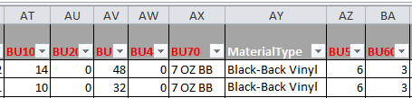

I created a vlookup for BU70 “=VLOOKUP(AY2,Material!$A$2:$B$8,2,0)” The AY column should be their “MaterialType” header.

Then there is the formula for price of material. As of 1/15/16 we do not need to perform the price step the software has been updated to perform this for us. Notice the columns in the formula that follows are the same ones from above. Here is the formula using a vlookup to get the price “=(((AT2*12)+AU2)*((AV2*12)+AW2))/144*VLOOKUP(BB2,Price!$A$2:$B$8,2,0)” it this formula column BB is the column for BU70 in a different sheet this would be AX in the clip above,

Once the formula is correct copy the formula to every row in the spreadsheet. Then copy the column data and paste it back using the special paste value technique.

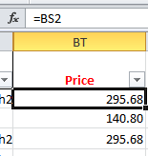Any hidden data will not be copied to your new sheet so verify your data once you create the new spreadsheet.

### 

### 

### Template and extensions

Fill in the templates that are going to used to produce the finished material. For material that calls for extensions you will need to fill out the following additional columns.

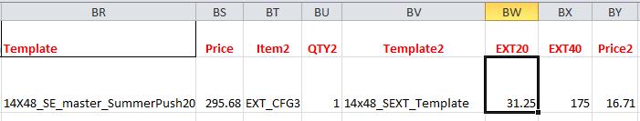Filtering at this point will be helpful so you can get all of your rows at the same time. The following is the current information. Item2 contains EXT_CFG3 with QTY2 a 1. EXT20 the height; EXT40 the width; and Price2 the price. So for a template 14x48 with an extension using this table fill in the columns as follows:

* EXT20 is 31.25
* EXT40 is 175
* Price2 is 16.71

As of 1/15/16 we do not need to provide the price it is calculated for you.

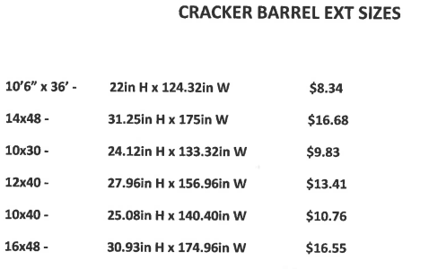

### Info

Lock the header

http://www.techonthenet.com/excel/cells/protect2007.php

### 

### Saving

Save the selected spreadsheet data in **Excel 97-2003 format**.

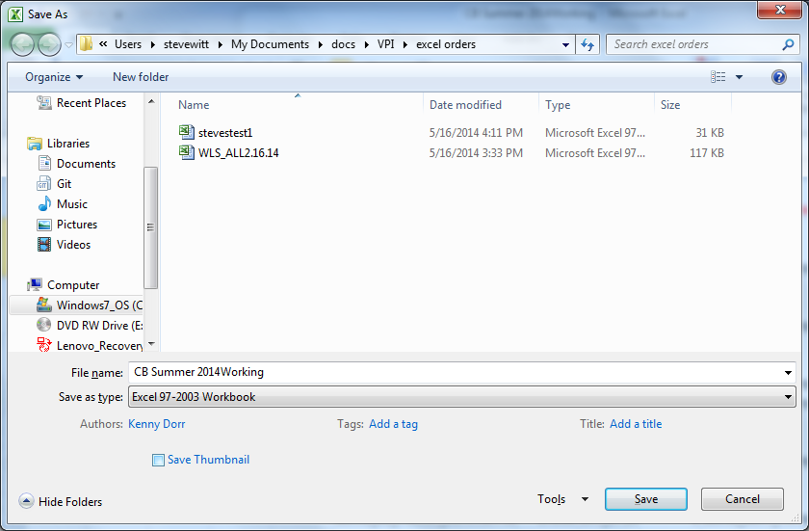

## IBS

You will want to look at the IBS client settings to prepare the system for the row data that will be inserted into the system.

### Sales Order Type

Set the direct print for the OO type so the orders are automatically set to a value of 20 which is confirmed. Make sure you hit OK until the type list shows up.

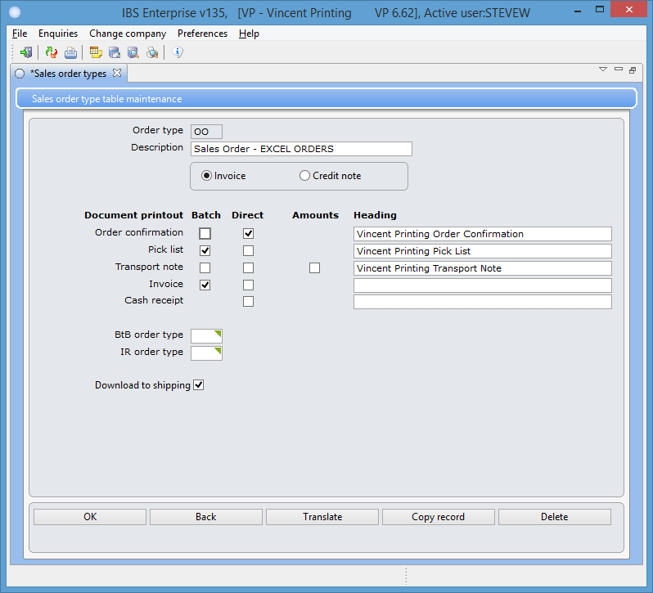

Note set this back once you are done.

### MFG Order

You have to set the MO type for the autoproofer as well.

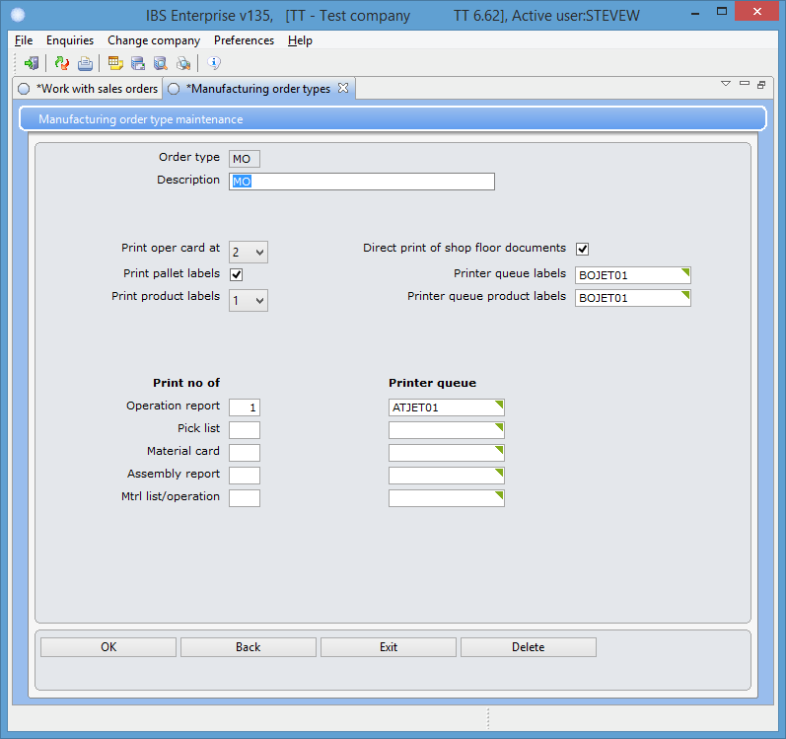

### Number Series

A new version of the code does not use the number series so to **no longer applies**.

Next set the order number for the Integrator to use.

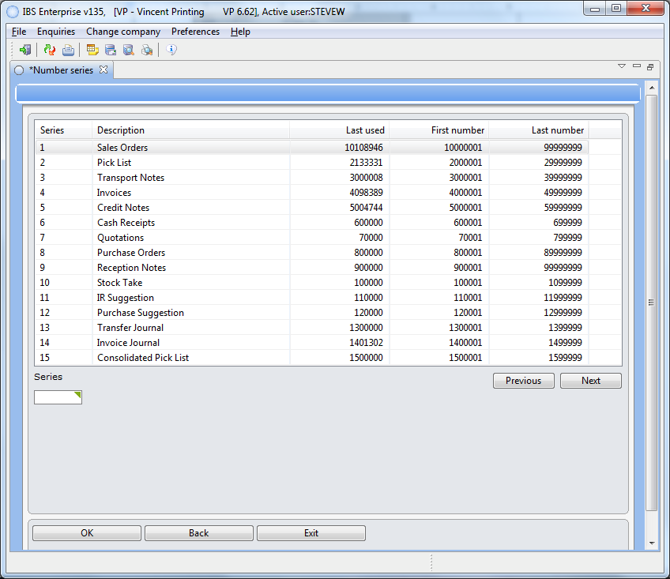

Copy the Last Used Sales Orders number into the

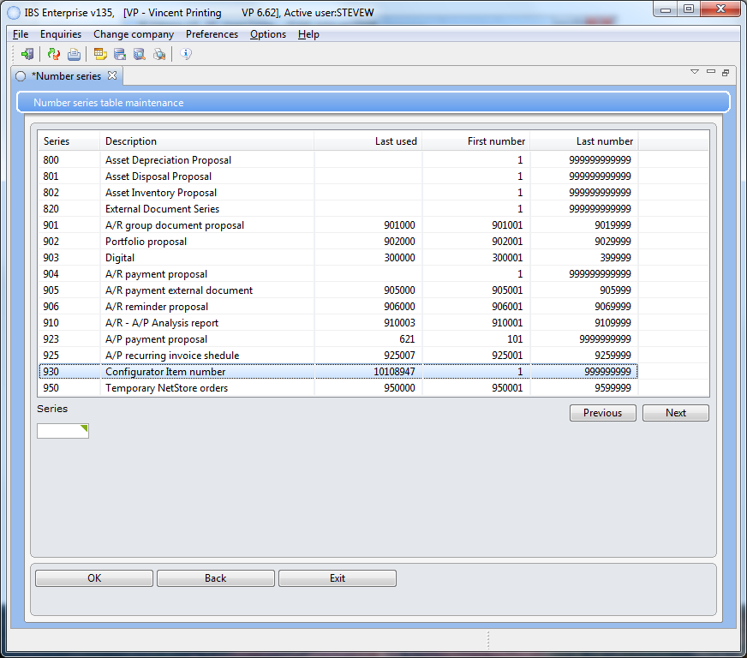

Configurator Item Number. Note: No one should be entering orders when you run this process or it will cause issues with the numbering in the orders that are created.

### Extended Number Series

Believe it or not IBS uses another table to hold the number series used for the indesign tables. Now I know that they want to give the customer the ability to customize their product but this is getting a little ridiculous.

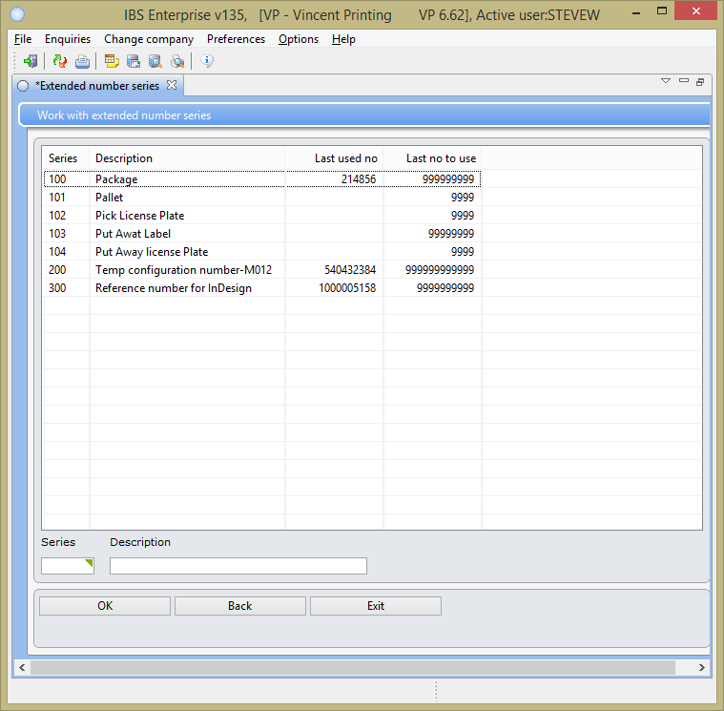

So make sure that this number does not step on the number in production.

You are now ready to drop the spreadsheet material in the hot folder on the Integrator server.

## Integrator

The following is the actual code with the heading names that the Integrator looks for the specific columns.

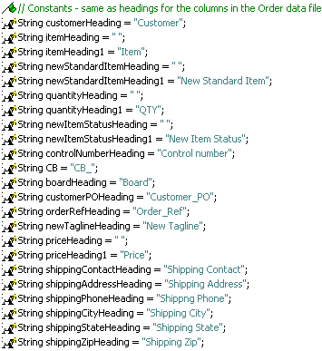

The Integrator has a file watcher service running on server 56 with the following configuration values. Notice the misspelling of “Shippng Phone” make sure you misspell it in the spreadsheet.

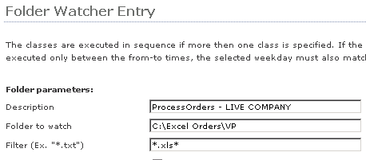 So you are going to place the spreadsheet you prepared with the selected material into the folder above on the server. If there is an excel error you can go to 56 using Task manager kill all of the excel processes to restart if needed.

## InDesign

InDesign is used to produce the finished board for the customer. The application uses specific columns and once again the headers in the spreadsheet need to have them in it.

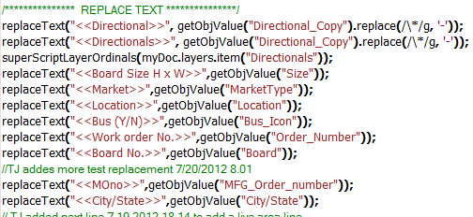

The InDesign server’s event log will have messages in it that help if problems occur.

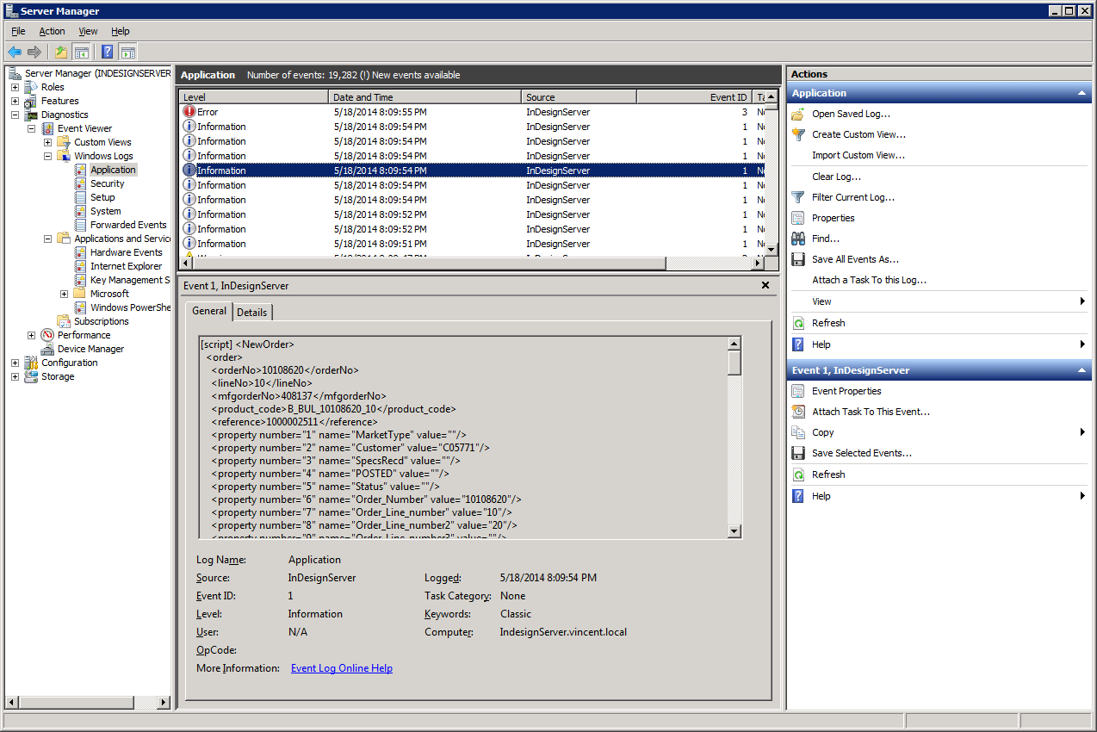

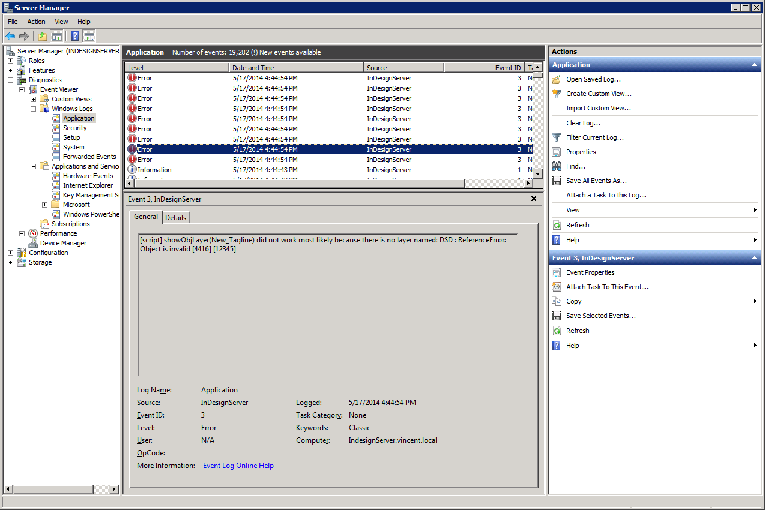This error shows that the column “New_Tagline” had a problem, the problem was that it was misspelled in the spreadsheet.

## Notes

This section contains notes on the project.

### Errors

From time to time believe it or not we get an error or two. In this section we have different notes on what to check or actions to take in case one happens.

The integrator log contains messages on from the program. For example if some has entered bad data and it gets passed the edits it could cause a sql error. That error message would be found in this log.

### Reset ihstat

At times you have to set the status on the InDesign tables to resubmit items. To do this use the following:

-- list the hdr data

select * from VT2662AFtt.Z3OINDIH where ihorno= 10114450;

-- list the attrs for a WO

e

where ihorno = 10114450;

-- update the hdr status

update VT2662AFtt.Z3OINDIH set ihstat = '0' where ihorno in (10114450);